

Лабораторная работа № 1
Тема: Знакомство с Windows Form.
По дисциплине: Разработка программных модулей

Выполнил: студент группы ИС-24
Пашина Валентина

г. Улан-Удэ
2026 г.

Form1.cs:
using System;
using System.IO;
using System.Windows.Forms;

namespace LR_1
{
public partial class Form1 : Form
{
string fileName;
public Form1()
{
InitializeComponent();
fileName = "Новый файл.txt";
toolStripStatusLabel1.Text = fileName;
}
private void fileToolStripMenuItem_Click(object sender, EventArgs e)
{
}
private void saveToolStripMenuItem1_Click(object sender, EventArgs e)
{
saveFileDialog1.FileName = fileName;
saveFileDialog1.InitialDirectory = Directory.GetCurrentDirectory();
if (saveFileDialog1.ShowDialog() == System.Windows.Forms.DialogResult.OK)
{
richTextBox1.SaveFile(saveFileDialog1.FileName);
fileName = saveFileDialog1.FileName;
toolStripStatusLabel1.Text = fileName;
}
}
private void newToolStripMenuItem_Click(object sender, EventArgs e)
{
richTextBox1.Clear();
fileName = "Новый файл.txt";
toolStripStatusLabel1.Text = fileName;
}
private void openToolStripMenuItem_Click(object sender, EventArgs e)
{
if (openFileDialog1.ShowDialog() == System.Windows.Forms.DialogResult.OK)
{
richTextBox1.LoadFile(openFileDialog1.FileName);
fileName = openFileDialog1.FileName;
toolStripStatusLabel1.Text = fileName;
}
}
private void saveToolStripMenuItem_Click(object sender, EventArgs e)
{
}
private void exitToolStripMenuItem_Click(object sender, EventArgs e)
{
Close();
}
private void aboutToolStripMenuItem_Click(object sender, EventArgs e)
{
AboutBox1 aboutBox = new AboutBox1();
aboutBox.ShowDialog();
}
}
}

AboutBox1.cs:
using System;
using System.Reflection;
using System.Windows.Forms;

namespace LR_1
{
partial class AboutBox1 : Form
{
public AboutBox1()
{
InitializeComponent();
this.Text = String.Format("О программе {0}", AssemblyTitle);
this.labelProductName.Text = AssemblyProduct;
this.labelVersion.Text = String.Format("Версия {0}", AssemblyVersion);
this.labelCopyright.Text = AssemblyCopyright;
this.labelCompanyName.Text = AssemblyCompany;
this.textBoxDescription.Text = AssemblyDescription;
}
#region Методы доступа к атрибутам сборки

public string AssemblyTitle
{
get
{
object[] attributes = Assembly.GetExecutingAssembly().GetCustomAttributes(typeof(AssemblyTitleAttribute), false);
if (attributes.Length > 0)
{
AssemblyTitleAttribute titleAttribute = (AssemblyTitleAttribute)attributes[0];
if (titleAttribute.Title != "")
{
return titleAttribute.Title;
}
}
return System.IO.Path.GetFileNameWithoutExtension(Assembly.GetExecutingAssembly().CodeBase);
}
}

public string AssemblyVersion
{
get
{
return Assembly.GetExecutingAssembly().GetName().Version.ToString();
}
}

public string AssemblyDescription
{
get
{
object[] attributes = Assembly.GetExecutingAssembly().GetCustomAttributes(typeof(AssemblyDescriptionAttribute), false);
if (attributes.Length == 0)
{
return "";
}
return ((AssemblyDescriptionAttribute)attributes[0]).Description;
}
}

public string AssemblyProduct
{
get
{
object[] attributes = Assembly.GetExecutingAssembly().GetCustomAttributes(typeof(AssemblyProductAttribute), false);
if (attributes.Length == 0)
{
return "";
}
return ((AssemblyProductAttribute)attributes[0]).Product;
}
}

public string AssemblyCopyright
{
get
{
object[] attributes = Assembly.GetExecutingAssembly().GetCustomAttributes(typeof(AssemblyCopyrightAttribute), false);
if (attributes.Length == 0)
{
return "";
}
return ((AssemblyCopyrightAttribute)attributes[0]).Copyright;
}
}

public string AssemblyCompany
{
get
{
object[] attributes = Assembly.GetExecutingAssembly().GetCustomAttributes(typeof(AssemblyCompanyAttribute), false);
if (attributes.Length == 0)
{
return "";
}
return ((AssemblyCompanyAttribute)attributes[0]).Company;
}
}
#endregion
private void okButton_Click(object sender, EventArgs e)
{

}
}
}
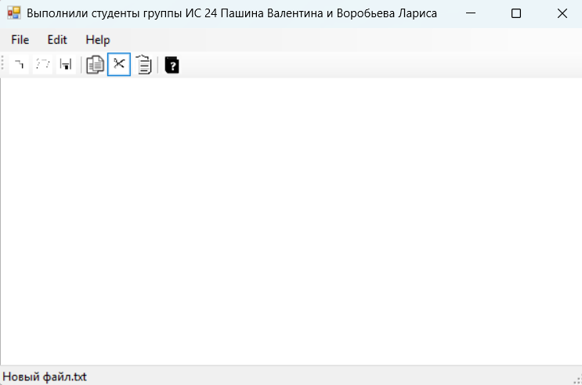
Рис.1 «Результат»

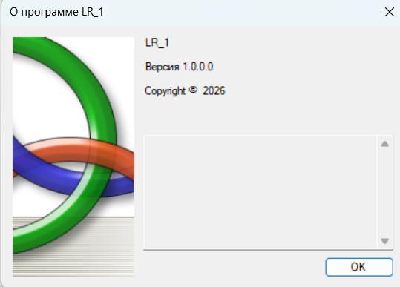
Рис.2 «Результат»

